State of Florida
STATE EXPENDITURE PLAN – Amendment _ (December 2020)
Submitted Pursuant to the Spill Impact
Component of the RESTORE Act
33 U.S.C. § 1321(t)(3)

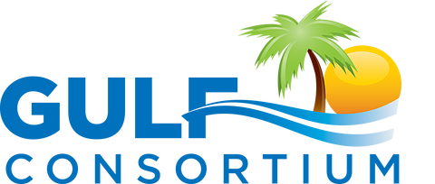

Proposed Projects, Programs, and Activities
This section is for completely new projects only.
For projects currently in the SEP that need scope changes or other revisions, see the section titled “SEP project timing and cost revisions and scope changes.”
PROJECT NO. ___

County Name
Project Title – FOR COMPLETELY NEW PROJECTS ONLY – not in original SEP

Project Description – Project Name
Overview and Location
Insert Text
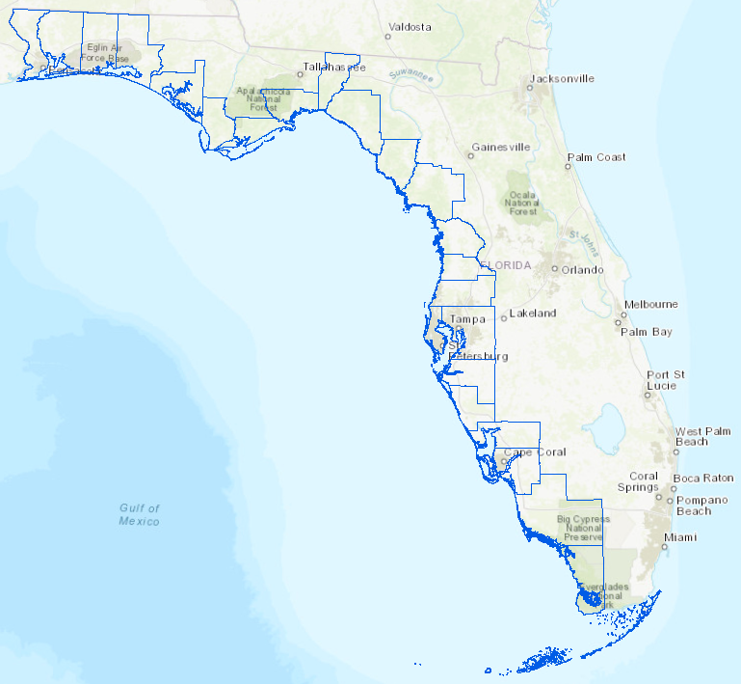

Need and Justification
Insert Text

Purpose and Objectives
Insert Text

Project Components
- Insert Text

Insert Text

Contributions to the Overall Economic and Ecological Recovery of the Gulf
Insert Text

Eligibility and Statutory Requirements
… Pick from the following:
- Eligible Activity 8: Planning Assistance (primary)
- Eligible Activity 9: Administrative Costs
- Eligible Activity 1: Restoration and protection of the natural resources, ecosystems, fisheries, marine and wildlife habitats, beaches, and coastal wetlands of the Gulf Coast region
- Eligible Activity 6: Infrastructure projects benefiting the economy or ecological resources, including port infrastructure
- Eligible Activity 7: Coastal flood protection and related infrastructure
- Eligible Activity 10: Promotion of tourism in the Gulf Coast region, including recreational fishing
- Eligible Activity 11: Promotion of the consumption of seafood harvested from the Gulf Coast region

Comprehensive Plans Goals and Objectives
… Pick from the following:
- Goal 1: Restore and Conserve Habitat: Restore and conserve the health, diversity, and resilience of key coastal, estuarine, and marine habitats.
- Goal 2: Restore Water Quality and Quantity: Restore and protect the water quality and quantity of the Gulf Coast region’s fresh, estuarine, and marine waters,
- Goal 3: Replenish and Protect Living Coastal and Marine Resources
- Goal 4: Enhance Community Resilience
- Goal 5: Restore and Revitalize the Gulf Economy: Enhance the sustainability and resiliency of the Gulf economy.
This project supports the following Council objectives, … Pick from the following:
- Objective 1: Restore, Enhance, and Protect Habitats
- Objective 2: Restore, Improve, and Protect Water Resources
- Objective 3: Protect and Restore Living Coastal and Marine Resources
- Objective 4: Restore and Enhance Natural Processes and Shorelines
- Objective 5: Promote Community Resilience
- Objective 6: Promote Natural Resource Stewardship and Environmental Education
- Objective 7: Improve Science-Based Decision-Making Processes
- Objective 8: Restore, Diversify, and Revitalize the Gulf Economy with Economic and Environmental Restoration Projects.

Implementing Entities
Insert Text

Best Available Science and Feasibility Assessment
Insert Text

Risks and Uncertainties
Insert Text

Success Criteria and Monitoring
Insert Text

Project Milestones and Schedule
MILESTONE | YEARS FROM MONTH APPROVAL
 | 1 | 2 | 3 | 4 | 5 | 6 | 7 | 8 | 9 | 10 | Deliverable (Y/N)
 |  |  |  |  |  |  |  |  |  |  | Y
 |  |  |  |  |  |  |  |  |  |  | Y
 |  |  |  |  |  |  |  |  |  |  | Y

Budget and Funding Sources
Insert text
Below is example milestones; update milestones and amounts:
MILESTONE | ESTIMATED TOTAL DOLLARS | ESTIMATED POT 3 ALLOCATION
Total Cost
COMMITTED FUNDING SOURCES
Spill Impact Component |  | $0
Direct Component |  | $0
Other grants or co-funding |  | $0
Other County funds |  | $0
Total Committed Funding |  | $0
Budget Shortfall |  | $0

SEP project timing and cost revisions and scope changes

________ County
Describe changes in scope, budgets, timing, deliverables.

See the examples below from SEP amendment #2.

Okaloosa County
The estimated costs and sequencing of projects in Okaloosa have been revised to reflect plans for project 3-5 “Veterans Park Living Shoreline” to start sooner than originally planned (2020 instead of 2031. The Spill Impact Component total project cost for project 3-5 is $890,875 for design and permitting efforts. Efforts planned in project 3-1 “Coastal Stormwater Retrofit Program” ($4,584,478 Spill Impact Component project total) and 3-2 “Offshore Fish Aggregating Devices (FADs)” ($592,792 Spill Impact Component project total) have been moved to later years to accommodate Veterans Park Living Shoreline beginning earlier, with minor impacts on the total annual budgeted amounts. Project 3-1 is now planned to start with Pot 3 funded efforts in 2025 and Project 3-5 is now planned to start with Pot 3 requests in 2023. These adjustments do not change the objectives or success criteria from what was planned in the original SEP.

Wakulla County
The planned Pot 3 funding for Wakulla County’s project 8-3 “Artificial Reef and Oyster Habitat Enhancement” has been removed from the SEP. Additionally, the Old Oaks Place Trail, Skipper Bay Park, Spring Creek, and Marshes Sands phases of project 8-2 no longer have Pot 3 funding requests in order to accommodate the Pot 3 request increase for project 8-1.
An additional project component has been added to project 8-1 “Wakulla Springshed Water Quality Protection Program.” The original SEP included effort for “Otter Creek WWTP Upgrade Feasibility Plan.” This amendment increases the effort substantially for Otter Creek WWTP from feasibility to engineering and construction. Wakulla County is presently conducting a feasibility study to fully document the County’s existing on-site sewage treatment and disposal system (OSSTD) and central sewer systems. This study will provide an inventory with location and condition of septic systems located in the Wakulla Springs protection area; information on county and privately-owned wastewater treatment facilities; GIS maps; remediation recommendations for upgrading or eliminating septic systems; financing options; and a legal analysis. Preliminary analysis however, is already indicating that a new train will be needed due to new growth and conversions of existing OSSTD to central sewer. Upon completion, this feasibility study will inform the Engineering and Design for the WWTP expansion as part of project 8-1.
In anticipation of reaching capacity a third train will be needed. Therefore, this project is seeking SEP funds for engineering services and construction costs for a third train in the Otter Creek WWTP. About $500,000 is estimated for design services and about $9M is planned for the Pot 3 construction costs for Otter Creek WWTP. To accommodate the increased amounts for construction for the Otter Creek WWTP, the Sewer Access Fees of project 8-1 were removed from Pot 3 funding requests. These adjustments do not change the objectives or success criteria from what was planned in the original SEP. All updated costs and milestones are documented in Table 1.

Best Available Science
A recent Basin Management Action Plan (BMAP) for this area prioritizes WWTP expansions as it is expected that nutrient contributions from WWTP will increase as OSSTD are removed (FDEP 2018). Expanding WWTP capacity is also consistent with the water quality improvement strategies prioritized in the St. Marks and Apalachee Bay SWIM Plan (NWFWMD, 2017). It is expected that more detailed BAS assessments will be completed as part of funding applications for project 8-1.
- FDEP, 2018. Upper Wakulla River and Wakulla Spring Basin Management Action Plan. Division of Environmental Assessment and Restoration Water Quality Restoration Program: Florida Department of Environmental Protection, with participation from the Wakulla Stakeholders.
- NWFWMD, 2017. St. Marks River and Apalachee Bay Surface Water Improvement and Management (SWIM) Plan.

Risks and Uncertainties
No significant risks related to the E&D and construction of the expansion to Otter Creek WWTP were identified. There is uncertainty related to the timing of permits for construction. Gulf Consortium and Wakulla County will coordinate with contractors as needed to ensure all permits can be obtained and all environmental compliance requirements are met.

Pasco County
The planned Pot 3 funding for Pasco County’s project 15-7 “Crews Lake Hydrologic Restoration” has been removed. This makes about $1.4M available for increased Pot 3 spending on parts of existing SEP projects or potentially a new project. The planned spending for that amount will be specified in a future SEP amendment. These adjustments do not change the objectives or success criteria from what was planned in the original SEP.

Implementation
This project allows for a new project in the SEP for ____, as well as updates to timing, projects, and cost projections for projects. …

